**Practical 10**

**Aim: Finding Location and IP Address**

(1)open

<https://grabify.link/>

and enter a valid url that will be opened when the user will click on your link which you have send.

And after that click on create URL.

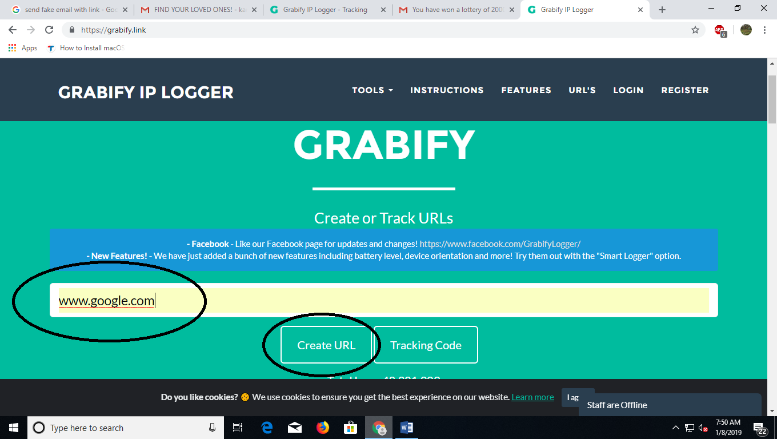

2.After that an dummy link will be generated which you can send to anyone to track their location and IP Address.A page Like this will be displayed below.

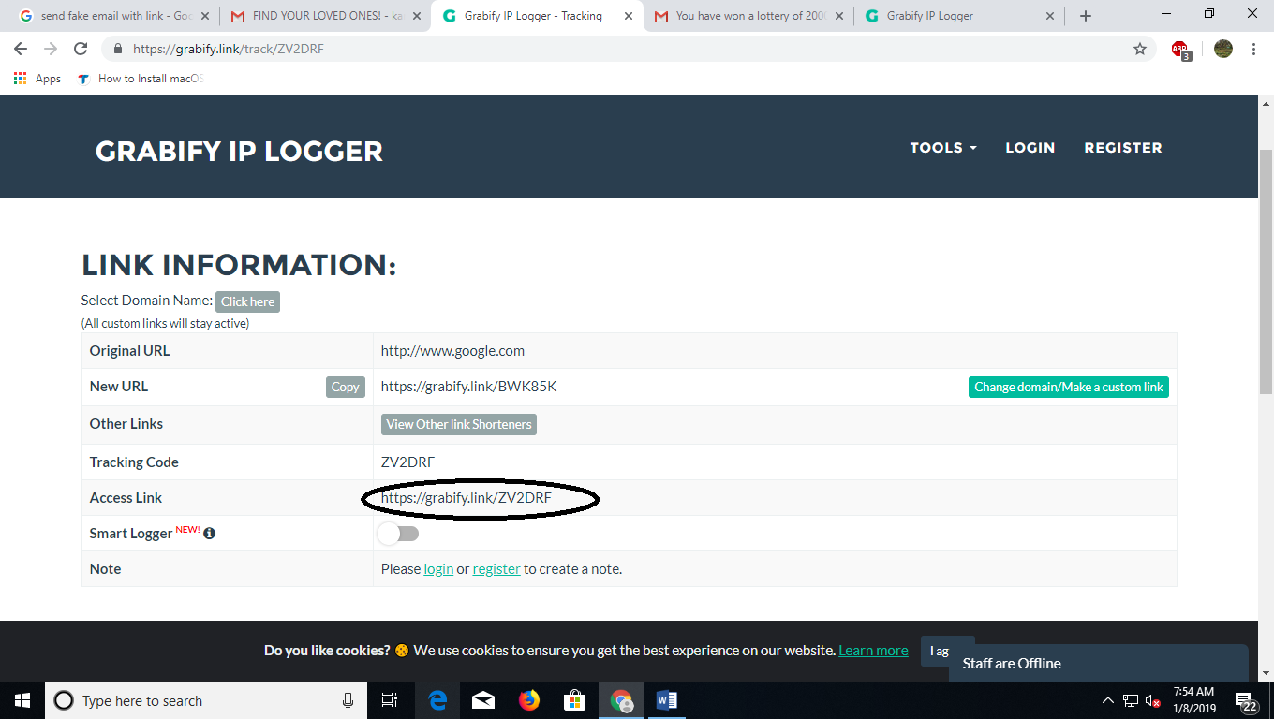

(3)Copy and paste the link in your email which you will be sending to the user.foreg:

And when the user will click that link another webpage will be opened(the url which you have specified)and you can track the location and IP Address of the user

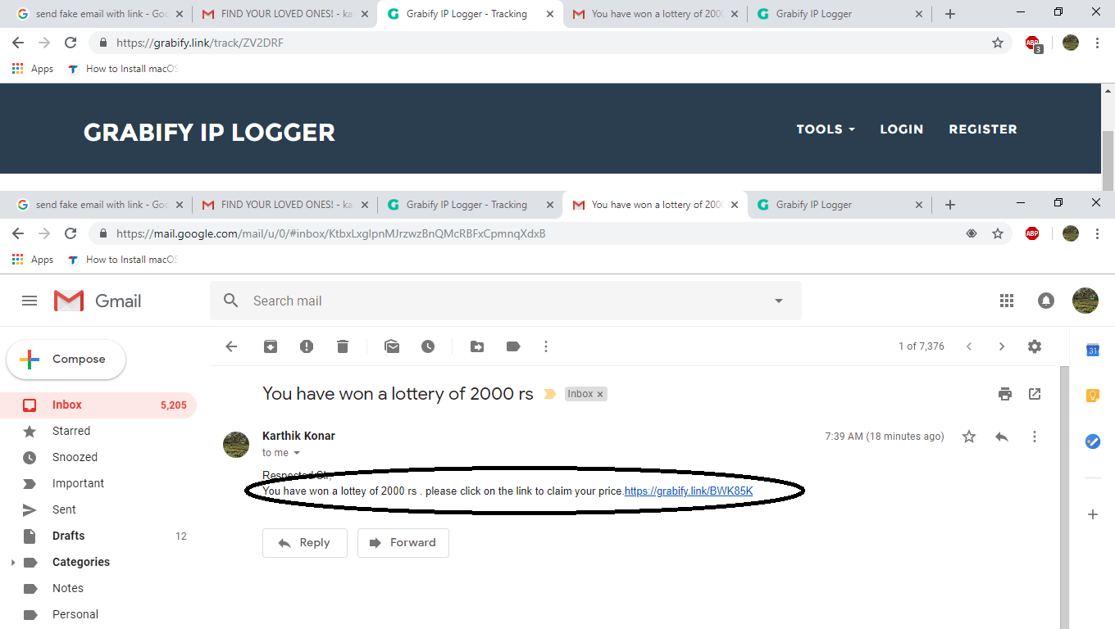

(4)When the user clicks on that link [www.google.com](http://www.google.com) will be opened because we had given that as our referring url

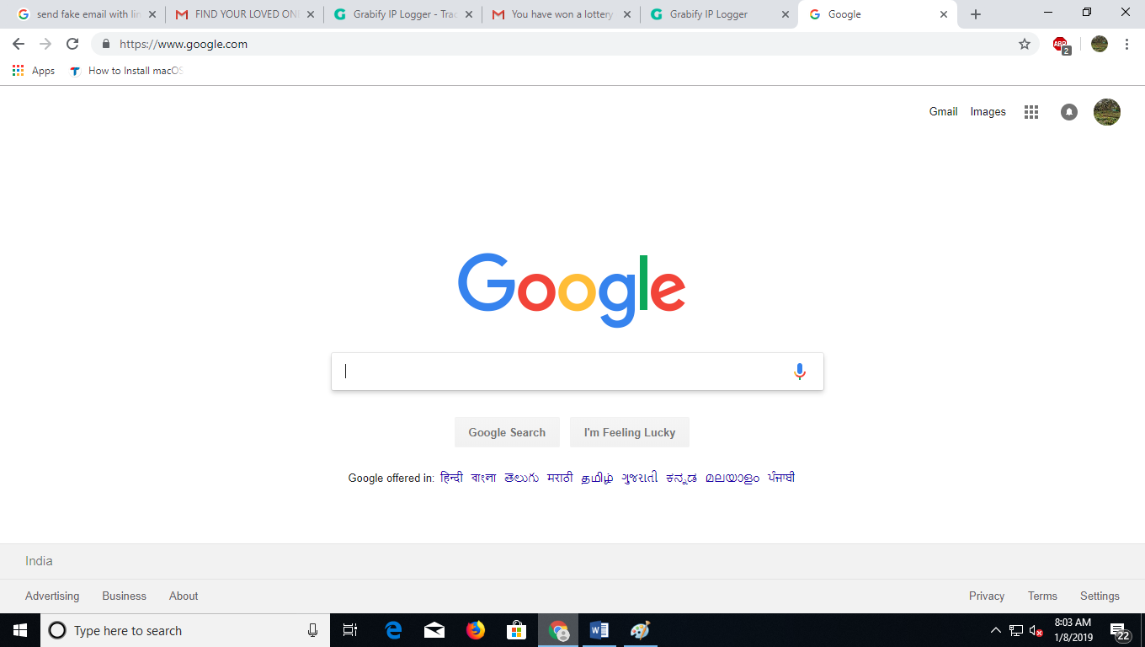

(5)After The User Has clicked on the link you will be able to track their location and IP Address

